Y4 Autumn 2020 Term 1 Curriculum Map (7weeks)
 | Literacy  Phileas’s Fortune  Phileas's Fortune reveals the power of language and self-expression. Words are important, but what is more significant is the sincerity and character behind what is actually being said. True self-expression comes from deep inside. And, in the end, heart is always more meaningful than money.  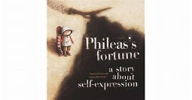 | Children will learn to:  Explore the text and answer questions to expand their understanding of the plot.  Research using thesauruses and dictionaries the meaning of words.  Making choices on the best synonym to use in their writing.  Use expanded noun phrases  Write a postcard/letter – Pretending to be Phileas.  Use drama to role play the character’s to understand their actions.

Geography  - Research facts on the River Nile and find out more about the physical features of rivers.  - Children will use mapping skills to locate islands in the Caribbean. Pupils will use Atlases and google maps to locate them.  History  - Black History study – Learn about the life of Nelson Mandela.  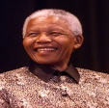 | Art/DT  Reviewing photographs from the 1960’s Study the work of a black artist such as Chris Ofili  https://artuk.org/discover/stories/ten-black-british-artists-to-celebrate  To develop a wide range of art and design techniques in using colour, pattern, texture, line, shape, form and space  Learn about the work of a range of artists,  STEM Project  To build The Windrush ship using recycled materials. | Science  States of Matter  Pupils learn about the differences between solids, liquids and gases, classifying objects and identifying their properties. Make links to STEM project in choosing appropriate states of matter (materials) according to its properties to construct a ship.  The children will work scientifically and collaboratively to investigate the weight of a gas.  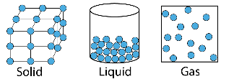

RE  How did belief in God affect the actions of people from the Old Testament?  Pupils explore significant people like: Abraham, Moses, Daniel Ruth and others to understand the concept of faith.  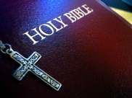 | Computing  Online Safety:  Keeping personal details safe and using a safe search engine; online identity  Word processing skills: formatting and fonts  Blogging – write up information on our History project | Core Learning Skills  Learning Behaviours – Learning with Others.  PSHE – Staying Safe and Healthy  The focus will be on:  Healthy body & minds – staying healthy, both mentally and physically.  1. Things that influence our choices over a healthy lifestyle.  2. Healthy choices for our bodies & the consequence of unhealthy choices.  3. Dealing with feelings – emotional & mental well-being.
Maths  Reasoning with larger numbers - 4 digits in all four operations ( +, -, x and ÷); data (charts). Learn new strategies to solve more complex equations. | Guided Reading  Weekly on a range of fiction and non-fiction books. | Homework  Research & study on Nelson Mandela. | Other (Trips etc)  Swimming TBC  ( subject to Covid regulations)

