Y4 Autumn 2020 Term 2 Curriculum Map (7weeks)
 | Literacy  The Wolves in the Walls  When Lucy hears noises from behind the wall she tries to warn her parents that there are wolves banging about. But her parents don't listen. When the wolves finally take over the house and Lucy and her family are evicted to live in the garden her parents realise perhaps they should have listened. So what was that noise Lucy heard coming from behind the wall...?  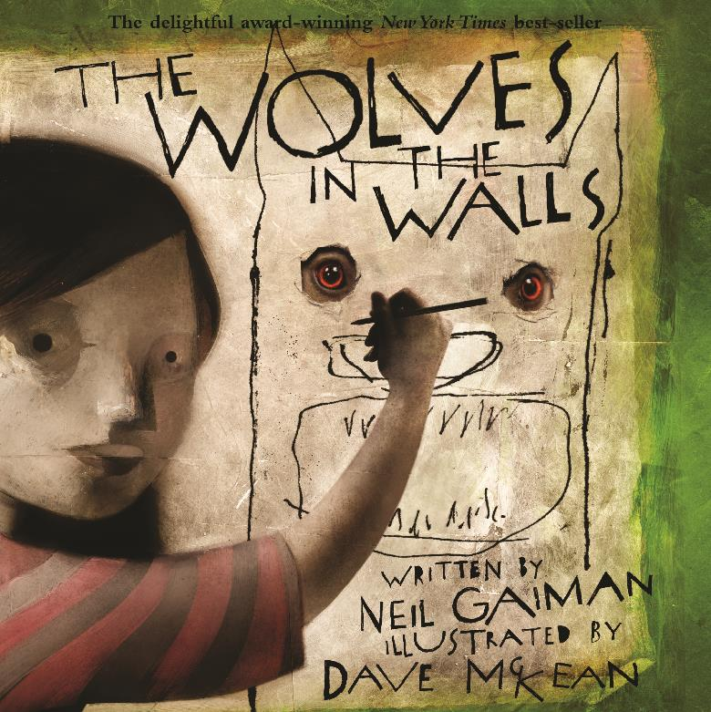 | Children will learn to:  Understand the effects of the authors word choices and layout of book to affect the reader’s mood. Pupils will continue to explore the use of vocabulary and how it affects the mood/plot/characters actions.  - Use conjunctions, adverbs and prepositions to express time and cause • Use the present perfect form of verbs in contrast to simple past tense • Use and punctuate direct speech Use commas after fronted adverbials • Use an appropriate choice of pronoun and noun within and across sentences to aid cohesion and avoid repetition • Indicate possession by using the possessive apostrophe with plural nouns  Pupils will build upon the rules for spellings to support their journey to learn the Year 3 and 4 statutory spelling list.

 |  | History  Ancient Egypt  Pupils learn about the ancient animals and their significance to Ancient Egyptians.  - Who were the Ancient Egyptians?  - Life as an Egyptian 3) Mummies  - Kings and Queens  - Hieroglyphics  - & 6) Religious beliefs and significance of animals |  |  | Art/DT  Ancient Egypt project from Deep Space Sparkle.  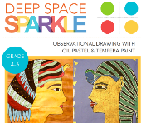 |  |  | Science  Living things and their habitats  - To be able to group living things using diagrams;  - To be able to classify vertebrates  - To be able to explore and use classification keys to help group, identify and name a variety of living things  - To create a classification key to sort living things  - To identify dangers to wildlife in our local environment  - To explore actions that affect and endanger species  - Assessment of learning
RE  The beatitudes and Peace at Christmas  What are the beatitudes and what do they mean to Christians?  - To understand the eight blessings taught by Jesus on the Sermon on the Mount.  - To express an understanding of the Beatitudes in today’s world by creating and designing posters to show the schools 3 main values.  What do Christians mean by peace at Christmas?  - To explore the meaning of inner peace and worldly peace.  - & 5) To understand the meaning of Jesus as the ‘Prince of Peace’  6) To explore the symbols of Peace. |  |  |  | Computing  Online Safety:  Keeping personal details safe and using a safe search engine; online identity  Word processing skills:  - Insert and format images.  - To use the main shortcut keys and the spell check tool.  - To insert and format a simple table.  - Changing font size, colour ( links to layout of Literacy book and the effect this has on the reader)  - Blogging – write up information on our local environmental research into Living Things and Habitats  (Science link).  - Research into Endangered species – using safe search engines. Creative commons licence for images. |  |  | PSHE & Core Learning Skills  Healthy & Happy friendships  - To explore the qualities and values that positive friendship has.  - To explore how to resolve issues between friends  - To understand the different communication channels to use to maintain good and positive friendships.  - To explore what to do and where to get help if you are being bullied.  - To explore and understand your own personal boundaries and those of others  - To explore personal boundaries linked to online safety
 | Maths  U3 Multiplication and Division.; U4 Discrete & Continuous Data ;U5 Securing Multiplication Facts;U6 Fractions |  | Guided Reading  Destination reader – whole class book ‘The BFG’ and original stories from Twinkl and school library. |  |  | Homework  Times table facts & practise skills taught in class; Comprehension and statutory spellings. |  |  | Trips  Victoria Park – Science

