SEND INFORMATION REPORT

St John of Jerusalem is a Church of England Primary School catering for children aged 3-11. Our current OFSTED rating is Good. We are an inclusive school, and we ensure that all pupils are included in all aspects of school life. We encourage all children to make the best possible progress at school regardless of their needs. Quality teaching is at the heart of our practice; we ensure our children have access to a broad and diverse curriculum to develop independent and team skills.

At St John of Jerusalem School, we welcome pupils with Special Educational Needs and make every effort to support them. All our classes are fully inclusive, and we have high expectations for all our children, including those with SEND. Every child is valued equally and given support according to their needs. By nurturing the whole child and building self-esteem, confidence grows, and children acquire the necessary skills to become responsible young people. Working in partnership with parents, all staff encourage children to develop a love of learning to aspire to achieve their best and support them to succeed.

We have clearly outlined the SEND Local Offer that we provide to ensure that we meet the needs of pupils with SEND. Schools and local authorities have been asked to provide a ‘local offer’ detailing what their school or authority can provide for children and young people with special educational needs and disabilities. We have set up this offer in a way that we hope answers most of the questions parents and careers may have when deciding where to place their child.

We hope the following pages will answer any questions you may have about our provision. Towards the end, there is a quick breakdown of what we offer for the main areas of need.

Just below are some common questions that parents may have.

What kind of SEN categories are there?
A child has SEN if they have significantly greater difficulty in learning than the majority of other children the same age; or if they have a disability which prevents or hinders them from making use of educational facilities.
Speech and language difficulties, emotional and social difficulties, and learning difficulties (specific and moderate) are all common forms of special educational need. Some children may have sensory or physical needs such as hearing or vision impairment.
It is possible that some children will have more than one need which is affecting their learning and progress.

Handy abbreviation support

SEN | Special educational needs && & &
SEND | Special Educational Needs  & Disabilities  &
SaLT | Speech and language  therapy
SLC | Speech, language and  communication
ASD | Autistic spectrum disorder
BESD | Behavioural, emotional  and social difficulties
CAMHS | Child and adolescent  mental health services
HLT | Hackney Learning Trust
MLD | Moderate learning  difficulty
SpLD | Specific learning difficulty
EP | Educational psychologist
MSP | My Support Plan
PSP | Pastoral support  programme
OT | Occupational therapist
EHCP | Education, Health & Care Plan
SEND Contact in the schoo
Our SENCo is responsible for coordinating SEND provision across the school.

What should I do if I think my child has SEND?
Initially speak to your child’s class teacher. They will be able to answer any questions you may have about your child’s progress. If you continue to have concerns then ask the office staff to arrange a meeting with our SENCo.

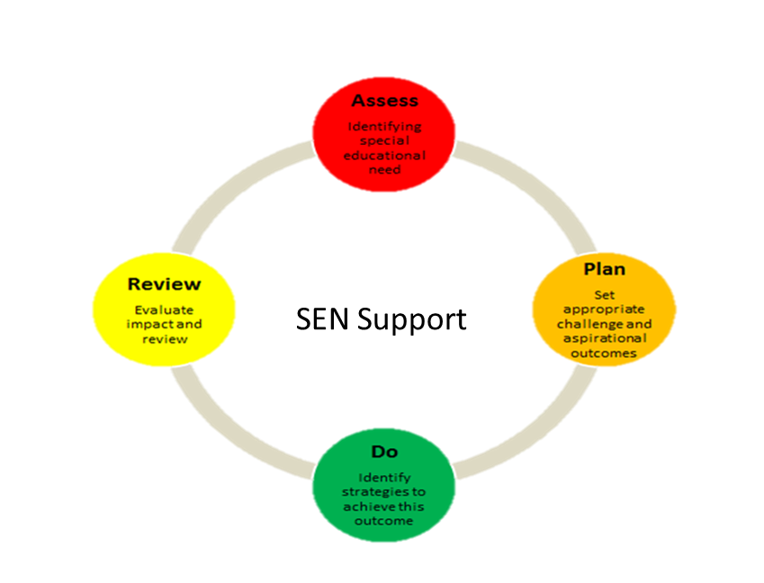

How does the school know if a child needs extra help?
We track children’s progress regularly through analysing assessment data. If a child is not making expected progress then we may start to introduce some extra support.
If there is a change in a child’s behaviour or progress, this may be another trigger for the introduction of extra support.
We also listen carefully to parents/carers if they raise any concerns. We recognise the importance of the child and their parents being involved in decision making.

SENCO and Class Teacher
.
How will I be told about my
child’s progress?
You will have the opportunity
to meet termly with your child’s class teacher, receive their Support Plan (SP) (if applicable) and discuss their progress.

You also have an opportunity to book an appointment with Carly Richards during parent’s evening to discuss your child’s additional needs if you wish.

If you wish to make additional appointments please ask in the office.
How will I find out what type of support my child will receive?

Your child’s class teacher will be the first person to inform you if we are providing extra provision for your child.

You will be informed by letter or in a meeting with the class teacher and Carly Richards. If needed Support Plan will be written which would show any extra provision that is being given to your child as well as the extra targets they have to support their SEN.
How will I know if my child has
SEN?
If the school is concerned and thinks your child has additional needs, you will be contacted by Carly Richards and asked to come in for a meeting. We will discuss what the concerns are and let you know what kind of additional support or external agency involvement (if any) that is being considered to support your child.

What is in place to help my child’s emotional wellbeing?

St John of Jerusalem is a very caring and supportive environment. All children are made aware that they can speak to a number of different staff to discuss any concerns.

We are very aware of the importance of the wellbeing of our pupils, and for that reason all staff are trained in how to listen to pupils. We also have ‘A-Space’ art therapists, who work children who may need some additional therapeutic input.

Will the school support me to help my child at home?
Your child’s class teacher will be happy to give you a number of ways you can support your child at home.
Carly Richards may meet with you to discuss strategies to use to support your child with their additional needs.
If an external agency, for example an EP or SaLT, is involved with your child, they will probably give you strategies to use at home as well.

.

How much progress should my child be making?
The average child should be working at expected standards and should achieve expected standard in each year group. Therefore if a pupil is in Year 2 she/he should be at Year 2 expected. Progress is not always linear, but we would expect all pupils to progress throughout the year from their starting point. We also have various assessment tools to assess pupils, depending on their own specific needs.

Which specialists does the school work with?

We work with a number of external agencies to support children in the school.
These include, but are not limited to:
- Speech and language therapists (SLT).
- Specialist teachers
- Educational psychologists
- Occupational therapists
- ‘A-Space’ Art therapist
- CAMHS clinicians
- FirstSteps
- SEN teachers & TAs
- Teachers for the most able
- Motor Skills PE Specialist

My child has health needs – how can the school help?
Carly Richards works closely with our school nurse. If your child has a medical condition, it is very important that you let Carly Richards know so that she and the school nurse can meet with you to set up a Care Plan for the your child’s condition. This plan will be shared with your child’s class teacher and any other staff who need to know. The school nurse will contact you and ask your health questions concerning your child. Once the nurse has completed the plan, you will be asked to sign and date the care plan. Please read, sign and return to the school immediately. You will also receive your own copy of the Care Plan.
This plan will be updated regularly. If your child has an allergy or a serious health condition this information is shared with all staff so that everyone can ensure they give the correct care to that child.

What specialist family support does the school offer?

Carly Richards works with a number of other agencies that she can refer families to for support. Parents of children with SEND may also like to contact ‘Hackney SENDIAGS (SEND Information, Advice & Guidance Service) who can offer information and support in the local area.

What training have the staff supporting children with SEND completed, or are currently completing?

Different members of staff have received training related to SEN, these have included:-
- How to support children with speech and language difficulties and run language groups
- How to support children on the autistic spectrum
- How to support children with social and emotional needs
- How to support children with medical needs

How will my child be included in activities in school?

Activities and school trips are available to all of our pupils.

- Risk assessments are carried out and procedures are put in place to enable all children to participate.
- If it is felt necessary, a parent or carer may be asked to accompany a child during the activity depending on the level of support required.

How do we involve parents and families in planning support?

All parents are actively encouraged to contribute to their child’s education.

This may be through:-

- Discussions with the class teacher
- Discussions with Carly Richards, the school SENCO; the Senior Leadership Team Termly MSP review meetings
- Annual EHCP review meetings (If necessary to child’s needs).
- Speech and Language phone consultations (If necessary to child’s needs).
- Education Psychologist/ Class teacher & Senco (If necessary to child’s needs).
- Coffee mornings
- Parent Meetings

How are the school’s resources allocated and matched to the pupils’ special educational needs? How are decisions made about how much support my child will receive?
The SEND budget is allocated each financial year. This money is used to provide additional support or resources depending on an individual’s needs.

Additional provision may be allocated after discussion between the class teacher, SENCO, Literacy and Numeracy Coordinators and Head teacher during our termly Pupil Progress reviews.
Resources may include deployment of staff depending on individual circumstances

How is the decision made about how much support my child will receive?

These decisions are made in consultation between parents, the class teacher, SENCO and Senior
Leadership Team. Decisions are based on termly tracking of pupil progress and as a result of assessments made by outside agencies.

How is the school accessible to pupils with SEND?

As a school we are happy to discuss individual access requirements. Currently we have:

• Low level access to Early Years and Key Stage 1 buildings
• Provision of FM equipment to hearing impaired pupils.

We are always willing to make adjustments to room allocations.

How will I know how St. John of Jerusalem Primary School supports my child?

Each pupil’s education programme will be planned by the class teacher. It will be differentiated accordingly to suit the pupil’s individual needs. This may include additional general support by the class teacher or from teaching support staff in class.

If a pupil has needs related to more specific areas of their education, such as spelling, handwriting, numeracy or literacy skills etc. then the pupil will be placed in a small focus group. This intervention will be run by the class teacher or the class teaching assistant. The length of time that the intervention will run will vary according to need but will generally be for one term. These interventions will be regularly reviewed by all involved to ascertain the effectiveness and impact of the provision and to inform future planning. These interventions are recorded on a Provision Map.

Pupil progress reviews are held every term. In these meetings the class teacher meets with the Senior Leadership Team to discuss the progress of all the pupils in their class. This discussion may highlight any difficulties pupils are experiencing, from which additional support can be planned.

Occasionally a pupil may need more expert help from an agency outside of school, such as Educational Psychology. If this is the case, a referral will be made with your consent and forwarded to the most appropriate support agency. In some cases the pupil may undergo a number of assessments to identify areas of strength and weakness.

.

Speech, language and Communication
Needs.

Quick identification and referral of children with Speech Language and Communication (SLC) needs to the Speech and Language service.

- We commission and buy in additional time from the Speech and Language service which means that one day each week our Speech and Language therapists are on site to support students.
- We implement all strategies recommended by professionals and monitor and record progress regularly.
- Speech and language groups are run in every year group by trained TAs who works alongside the SaLT in running language groups aimed at meeting those specific children’s needs.
- Our SaLT runs a number of training programmes to staff including:
- Lego Therapy
- Communicate in Print
- General support strategies
- Parents can request an appointment through Carly Richards.

Social, Mental and
Emotional Health

What support is there for Social, Mental and Emotional Health?
-The school’s behaviour policy ‘Stay on Green’ is applied consistently and fairly.
-Children whose behaviour is causing concern are placed on ‘behaviour charts’ which include weekly meetings with parents to discuss and review strengths and targets.
- Home/School communication is a key component of the policy and regular meetings are held with parents.
- Key staff are trained on ‘positive handling’ techniques.
-Individual pastoral support plans are written for children with more serious difficulties.
- Positive Handling Plans are put into place for children to ensure effective and personalised de-escalation strategies are shared for children who need this.
-Emotional Regulation support and the awareness of the Zones of Regulation.
- Educational Psychology service and CAMHS support.
-Weekly Art therapy sessions are in place for children requiring extra emotional support.
- Core Learning Skills lessons support positive behaviour and social skills.
-Social skills group are in place for particular Pupils.
-Reward systems which encourage positive behaviours: weekly Awards and
Behaviour Trophy, which are presented during Friday assemblies.
-Two children from each class are rewarded for their outstanding achievements and behaviour also in Friday assemblies.

Moderate and Specific

Learning Difficulties

- High quality teaching, which is differentiated and personalised in the classroom and support from class teacher and TA.
- Streaming of children for phonics from Reception in order to target support
- Individual and group support from TA and/or class teacher SENCO.
- Use of synthetic phonics to ground children early understands of sound and support decoding.
- Streaming of children for Supported Reading sessions from the Spring Term of Reception to Year 1.
- Use of physical resources (Numicon) in Numeracy.
- In KS1 daily phonics interventions and 1:1 weekly phonics interventions.
- In KS1 and 2 small group focus Numeracy interventions.
- Volunteer reading support for children not making expected progress.
- After-school Homework club for students including targeted groups of students.
- Termly assessments to track and monitor progress.
- Individual support available for children with Educational, Health and Care Plans.

.

Sensory and
Physical Needs

- Quick identification and referral of children to Occupational Therapy service
- We implement all strategies recommended by professionals and monitor and record progress regularly.
- We provide all required or requested resources e.g.: pencil grips, special scissors, support blocks, chewelry etc.
- Use of specialist teachers to implement plans to include strategies for managing sensory needs.
- Regular liaison with school nurse to ensure children with physical needs can access the school environment.
- Implementation of accessibility plan (please see website) to ensure that St. John of Jerusalem is accessible to a wider range of children with different
- needs.

For additional information on services available in Hackney, please visit the following website:
www.hackneylocaloffer.co.uk

