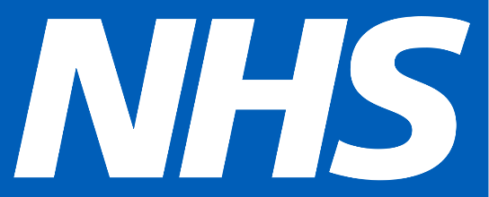 Riley James Treacy Guthrie
Year 6
1 Ambleside Close
Hackney, London.
E9 6EY
14/04/2020
Dear all the lifesavers and staff at the wonderful NHS,
My name is Riley-James, I am 10 years old and I am a pupil at St John of Jerusalem Primary school in Hackney.
On behalf of my family and I, we want to congratulate and thank you for all of the wonderful things you have done for all of the people suffering, whilst risking your own lives. You have saved lots of kids role models like; their mums, dads, grandmothers, teachers etc.
It’s lovely to hear when people suffering of COVID-19, are saved from the contagious disease by all of your wonderful staff, yet heart-breaking when you (the NHS) put your own lives in front of others, so I want to give a big BIG thank you to you ALL.
I want to say thank you to; the doctors, the nurses, the cleaners, the care workers and the life savers that help the elderly especially, whilst you guys try to put this horrible disease to its mighty end.
If I were you I would be annoyed and sad, since I have to put my life in danger! But instead of doing that, you (NHS) get on with saving lives and you all continue to fight this deadly disease. Whilst doing all of this, you are all very loving to everybody and always help anyone no matter what their circumstances.
So I just want to say a huge thank you, to you ALL for being so wonderful and caring. Thank you for being THE BEST NHS ❤
