Welcome to St John of Jerusalem Early Years Foundation Stage (EYFS)

Sarbjit (Nursery Teacher), Reem (Reception Teacher), Sharmain and Nefeli (Nursery Officers) and Rita (Learning Support Assistant) welcome you to St. John of Jerusalem Early Year Foundation Stage.

As the parent of a new child, there will probably be lots of questions that you want to ask and information that you need to know. We hope this booklet will answer some of these queries and give you an insight into our daily routine. Please feel free to speak to us at any time if you have any further questions.

Play

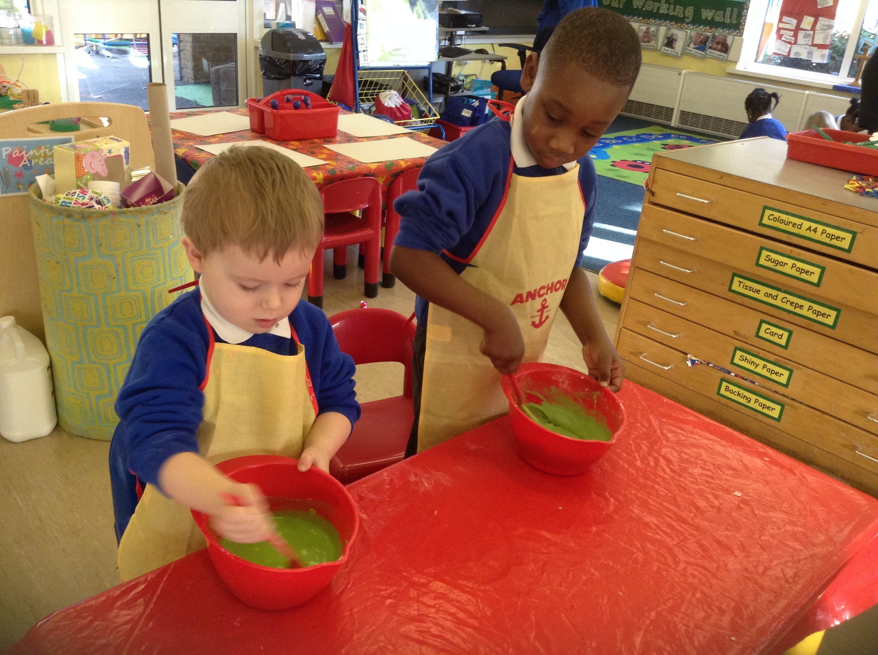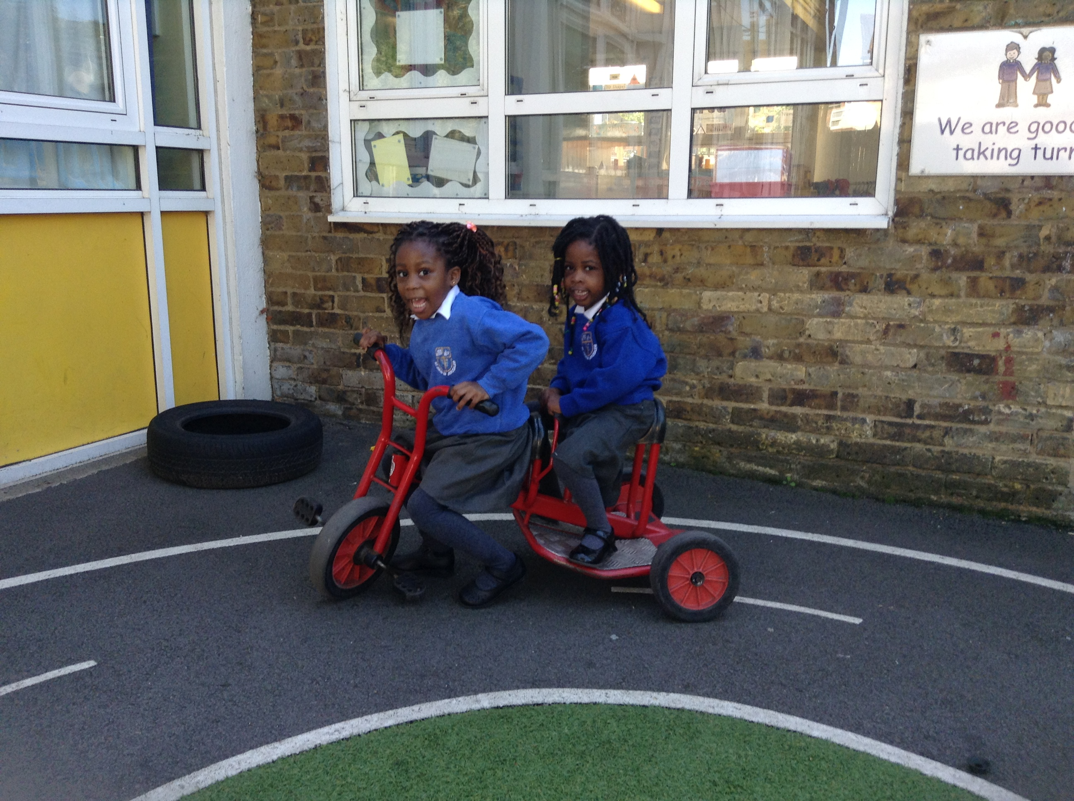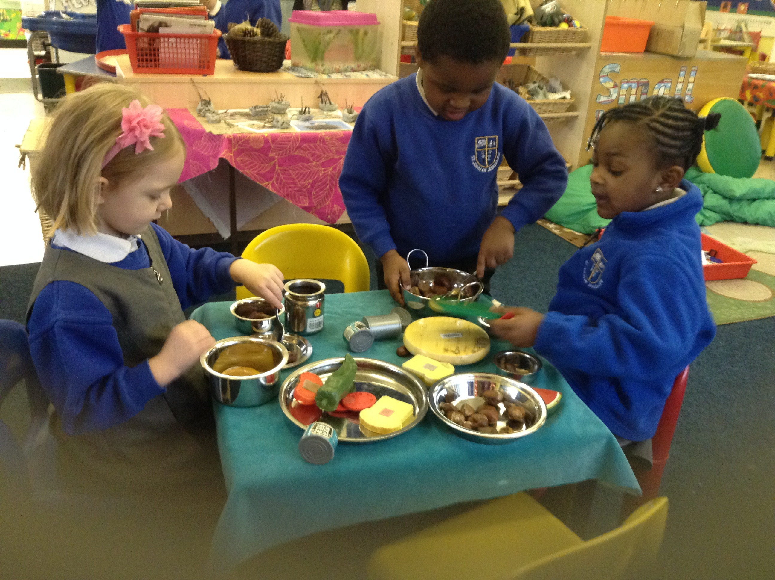

Play helps children to develop positive attitudes to learning; it also helps them to feel confident about themselves and their development.

Parents

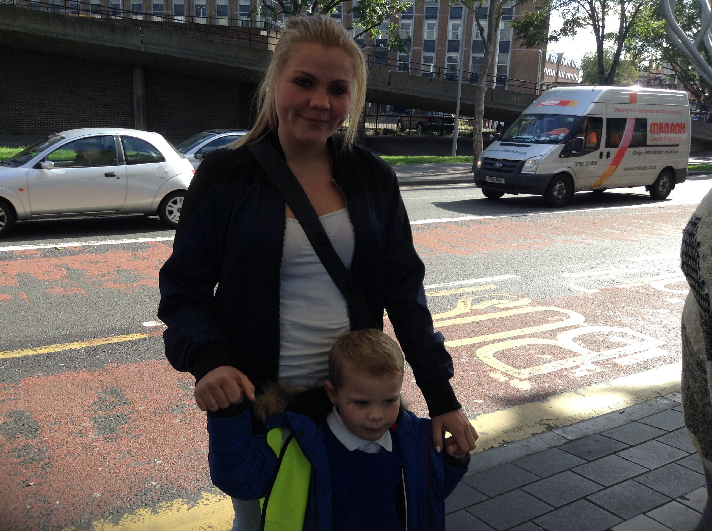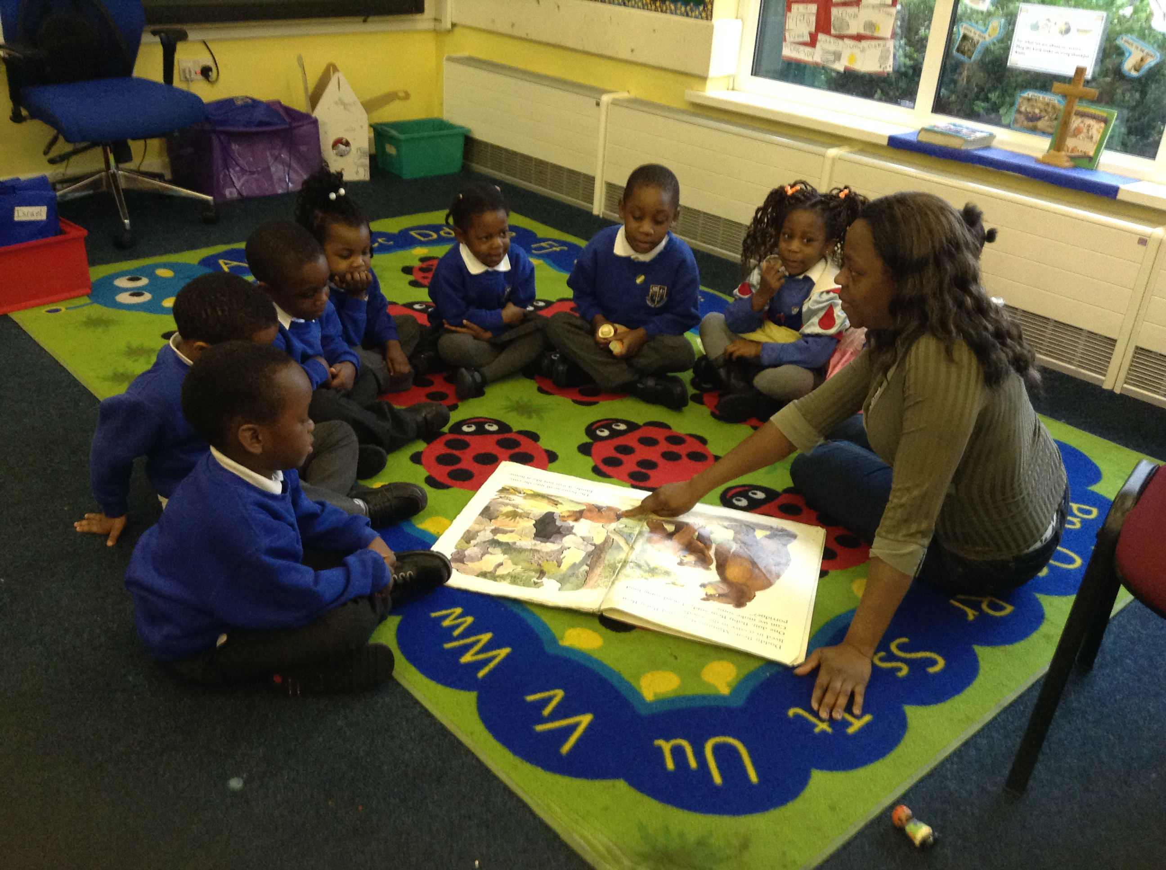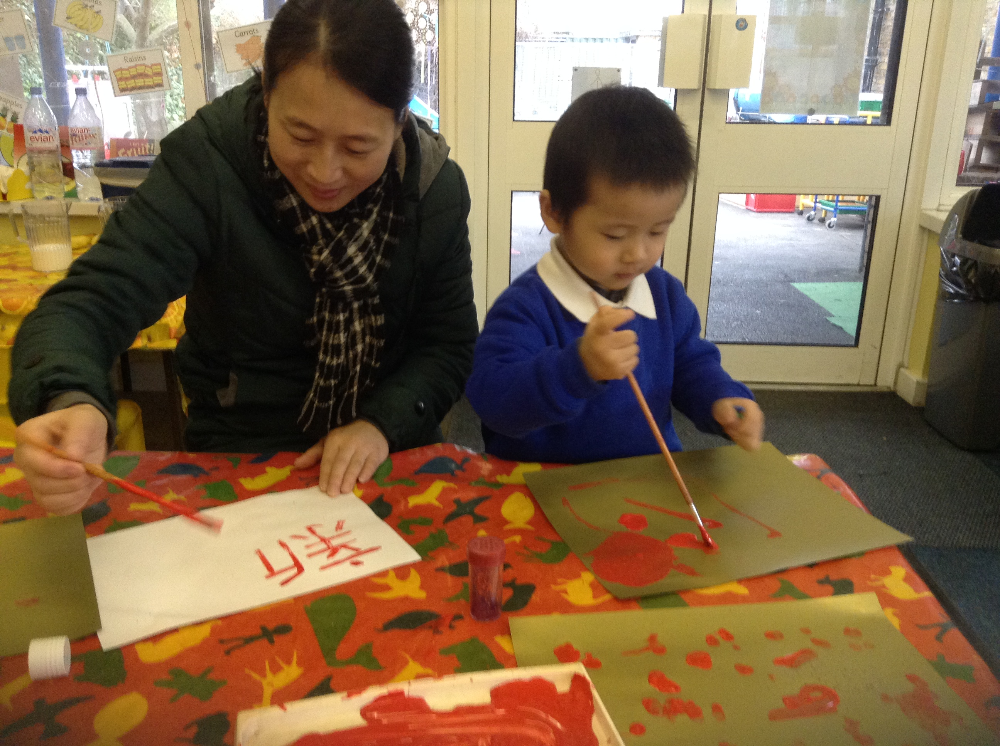
Parents are children’s first educators and we value your expertise and contribution. We welcome parents to volunteer in our school; this could be for one hour or more, it is up to you. If you have any skills you would like to share such as cooking, arts & craft, music/singing or if you like to read stories with the children or just help out generally, for example visits, you are very welcome; Dads in particular. Children always benefit from parents’ interest in their learning. We are available after school every afternoon at 3:30. This is an opportunity for you to share any questions or thoughts.
Home Visit

Coming to a new class for the first time can be daunting for a young child. Our home visits take place before your child starts, it will help you and your child to get to know us and allow us to get to know you. We will learn about your child’s family as well as favourite toys, books, etc. This will help your child to settle in.

Settling In

Children will start school in small groups. On your child’s first day s/he will stay for 1 hour (either a morning or an afternoon), accompanied by parents/carers. For the next few days, we ask that you attend with your child, to help them to feel secure. You can then gradually allow them to stay for longer periods without you. The transition from home to School is a very individual process and will be directed by your child’s individual need.

Staying Healthy
Snack Table
Children are offered and can freely access healthy snacks (including water, milk, apples, carrots, pears, satsumas and bananas) throughout the day.

Lunchtimes
The full-time children are offered hot, healthy and nutritious meals prepared on the premises. The children are encouraged to develop healthy habits by increasing their intake of vegetables and fruit.
Children having packed lunches, please ensure that these are healthy and balanced. This should not contain chocolate, snack bars, sweets, crisps, nuts or sweet/fizzy drinks. If in doubt about this please ask.

Curriculum

We use the Early Years Foundation Stage (EYFS) Curriculum Guidance to plan our learning environment. Every day we provide learning opportunities for all seven area of learning (as outlined in the Curriculum Guidance).

These activities are offered to children through adult guided, adult supported activities, independent learning and child-led activities when adults take the lead from the children’s explorations and ideas. Children will learn through active involvement and independent learning.

In addition to this the children also have weekly P.E., Spanish and Music sessions.

‘Show and Tell’
The children are invited to bring in something from home. This could be a favourite toy or a photograph, etc. This encourages children to be confident to speak to the class.

Observation and Assessment

We observe each child’s progress and make notes to help with planning for their learning and development. This helps us to keep track of your child’s progress. Children’s ‘Profile Books’ are available for you to share with your child at any point during the year. The Profile Book includes photographs and annotated work samples as well as your Child’s Voice and your contribution. The book will show children’s progress and help the children to reflect on their own learning. This will help them to see themselves as ‘learners’.
Throughout the year we have termly parent/carer consultations and at the end of the year, we will write a Report for all children moving to new class or school.

Behaviour and Expectations

In the EYFS we foster independence, self-confidence, motivation, self-worth and responsibility. We encourage all of the children to express themselves verbally and to seek support when they need it.
We provide an environment in which children’s emotional development will be nurtured and where respect for one another is of prime importance.

We regularly have ‘circle time’ where children are given the opportunity to speak about social and emotional issues in a safe environment. We will always discuss any concerns we have with you.

Book Bags

All children will receive a book bag on their first day. Then once a week they will have the opportunity to change their books. If your child wants the same book again and again, this is fine.

Each week children will take home the class bear. Children will be asked to draw pictures and you can take photographs and write what your child did with the bear.

School times

Full-time children’s day is 8:55am – 3:30pm.
Part-time morning children’s day starts at 8:55am and finishes at 11:55pm.
Part-time afternoon children’s day starts 12.30 and finishes 3.30pm.
Please arrive 5/10 minutes before session ends to ensure children do not get upset/distressed.

Arrangements for collecting children

It is essential that staff know who is permitted to take the children home. Children will only be allowed to leave the premises with appointed adults. If someone different is coming to collect your child, staff must be notified. Children under the age of 16 will not be allowed to collect pupils from Nursery.

CLOTHES

Uniform

Grey trousers/jogging bottoms/skirts/pinafore dresses/shorts
Royal blue sweatshirts/ cardigans/jumpers
White shirt/white polo shirt.
Blue gingham striped/checked dresses
Black/navy leather shoes or black/navy trainers with Velcro fastenings

Outdoor Clothing
The Norwegians say “There is no such thing as bad weather just bad clothing!” As part of the EYFS Curriculum we encourage all children to explore, investigate and play in the outdoor area, most of the day, every day, so waterproofs and wellies are essential especially when it is windy, raining or snowing.

Spare Clothes
You will need to ensure there is spare set of clothes in case your child needs changing, eg underwear, socks, trousers, tops, fleece, shoes.

NB Please write child’s name on clothes with a permanent marker.

