BLACK HISTORY MONTH
CULTURAL LUNCH MENU
Tuesday, 19th October 2021
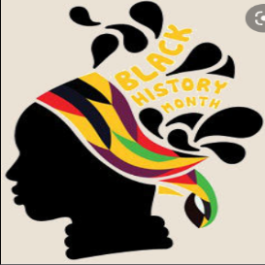
Barbeque Chicken Wings
Vegetable Samosas
Jollof Rice
Aki & Saltfish
Plantain
Fried Dumplings
Corn on the Cob
Salad
Coleslaw

Marble Cake
Selection of Fruits

