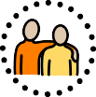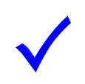What I Must do to Keep Safe Online and With Devices







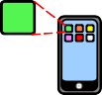Online means anything connected to the internet. Most devices and apps are connected to the internet.

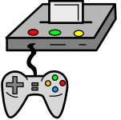



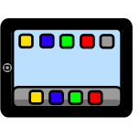Devices are technology like: computers, laptops, games consoles,

tablets and smart phones.

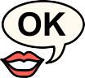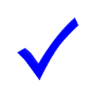I will only use the devices I am allowed to use.



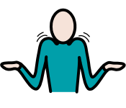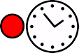****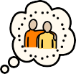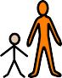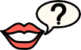



I will ask a trusted adult before I use new websites, games or apps.

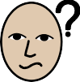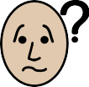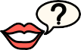****

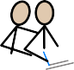

I will ask for help if I'm stuck or not sure.

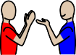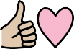****

I will be kind and polite to everyone online.

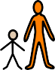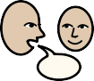***I will tell a trusted adult if I feel worried, scared or nervous when I am using a device.

****

I will tell a trusted adult if I feel sad, angry or embarrassed when I am using a device.

I will tell a trusted adult if I feel bad or unsafe when I am using a device.

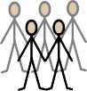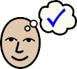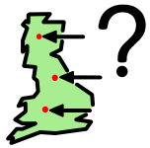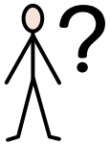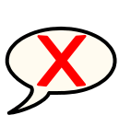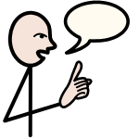I know people online sometimes tell lies.

They might lie about who they are or where they live.



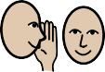

I never have to keep secrets from my trusted adults.

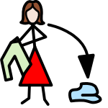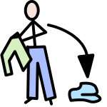

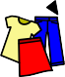

I will not change clothes or undress in front of a webcam.

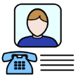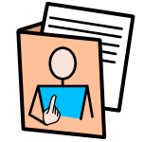****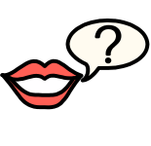I will always ask a trusted adult before telling anyone my private



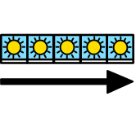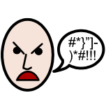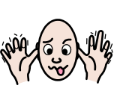information or location.

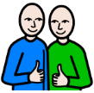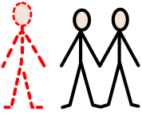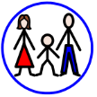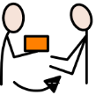I know that anything I do or say online might stay there forever.

It can be given to my family, my friends or strangers.

This could make me feel sad or embarrassed.

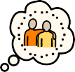



My trusted adults are ________________ at school



My trusted adults are ________________ at home

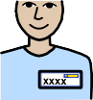

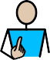

My name is ________________