Y1 Autumn Term 2 Curriculum Map (7weeks)
 | Literacy  The Queens Hat  A sudden gust of wind sets off a marvellous London adventure for the Queen, the Queen's men and one very special hat. So let's follow one determined, daredevil queen through the zoo, over Tower Bridge and up Big Ben... just where will that hat land?  LI: To be able to predict what might happen based on what I know.  LI: To be able to read the story together, modelling the application of phonics and fluent reading.  LI: To be able to sequence what happens in the story.  LI: To be able to skim and scan a text and to write simple sentences about the wind.  LI: To be able to write a grammatically accurate question and to use the conjunction ‘and’.  LI: To be able to analyse language and discuss the importance of using the right words.  LI: To be able to create a plan for a diary by sequencing events.  LI: To be able to write a diary entry for a character of their choice.  LI: To be able to plan and write their own version of The Queen’s Hat/a page of a class narrative.  LI: To be able to write a narrative/page of a class story.  LI: To be able to compare and contrast Steve Antony’s style.  LI: To be able to talk about language and word choices.  LI: To be able to use inference and retrieval skills to answer questions.  LI: To be able to write grammatically accurate sentences in role as the sneaky swan.  LI: To be able to explain what is happening in the final pages and explore what characters may be saying.  LI: To be able to further contrast the two books and to discuss and record similarities and differences.  LI: To be able to use noun phrases for description.  LI: To be able to write in the style of Steve Antony.  Guy Fawkes  Children will be learning about Guy Fawkes, thinking about his life and telling the story of the Gunpowder Plot. Making their own Guy Fawkes. Role-play the Gunpowder Plot. Make artworks inspired by Bonfire night and learn about fire safety. | Children will learn to:  Predict what might happen based on what they know- using capital letters for names of people. Developing an understanding of the plot and analysing the language used in the text. Exploring the character of the ‘sneaky swan’ through role play – why might the swan need the bag? Using contractions – ‘and’ to join words and phrases and the pronoun ‘I’.  - Prediction- who is the queen going to see?  - Sequence- sequencing the events in order  - Speech bubbles- writing in role as the wind  - Diary entry- retelling the story as a chosen character.  - Own versions of the story  - Sentence work- Can we improve Steve Antony’s sentences?  - Lists- Alliterative animals, and what does the Queen have in her handbag?  - Why I stole the Queen’s handbag- Why I stole the Queen’s handbag  Children will learn to:  Learn about the Gunpowder plot  Understand Guy Fawkes’ role in the Gunpowder plot  Act out a specific event in the Gunpowder plot  Understand why we celebrate bonfire night  Describe their experiences of bonfire night

History  Guy Fawkes and the Gunpowder Plot  LI: To be able to explain what bonfire night is.  LI: To be able to find out about James 1 of England.  LI: To be able to find out who Guy Fawkes was.  LI: To be able to find out what happened next in the Gunpowder plot.  LI: To be able to think about why fireworks are lit on November 5th. | Art/DT  LI: To be able to make a firework painting.  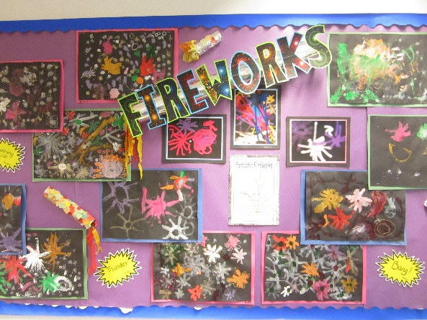 | Science  Seasons  LI: To be able to find out what the weather is like in winter.  What are toys made from? - identifying materials and its properties  LI: To be able to identify and name a variety of everyday materials used to make toys.  LI: To be able to explore and describe wooden toys and their properties.  LI: To be able to explore and describe plastic toys and their properties.  LI: To be able to explore and describe metal toys and their properties.  LI: To be able to explore and describe fabric toys and their properties.  LI: To be able to recap what we have learnt about what material toys are made from.

RE  Why are saints important?  LI: To be able to understand what makes a saint.  LI: To be able to develop an understanding of the importance of saints and all Saints day to Christians.  Nativity Characters  LI: To be able to understand what the ‘good news’ is.  LI: To be able to understand who Mary and Joseph are.  LI: To be able to understand the role of the shepherds in the Christmas story.  LI: To be able to understand why Herod was jealous. | Computing  Cyberbullying  LI: To be able to understand what cyberbullying is and that it is not OK.  Word processing skills  LI: To be able to type on a keyboard.  LI: To be able to type symbols and save files.  LI: To be able to edit text.  LI: To be able to type on a keyboard.  LI: To be able to select and format text.  LI: To be able to format the font. | Core Learning Skills  PSHE  1) LI: To be able to learn about what a mind-set is and the difference between a fixed and a growth mind set.  2) LI: To be able to learn about how to get on with other people, how to be friendly with others and the qualities that make a good friend.  3) LI: To be able to learn about kind and unkind actions, how to be kind to each other and how to recognise when a friendship makes you feel unhappy.  4) LI: To be able to learn about how to get on with others, the importance of sharing and taking turns and the importance of working together.

Maths  U3- Shapes  U4- Numbers within 20  U5- Addition and subtraction within 20 | Guided Reading  Where possible choose books related to:  Materials, fireworks, toys | Homework  Science- look around your house and draw five objects you have found. Write what the material is and describe the simple properties of that material.  Topic- To research some of the differences in how people such as Guy Fawkes lived, compared with today. | Other  The Nativity

