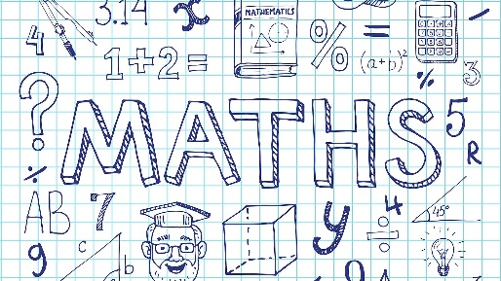
Homework 9. 10. 2020
Solving word problems

1) 124 people were at the top of Blackpool Tower. The lift brought ten more people to the top. How many people were there altogether?
2) John had scored 532 points in the darts game. With his last dart he scored 100. What was his total score?
3) 381 people were in the theme park at 5:30 p.m. At 6 p.m., one hundred people left on coaches. How many people were left in the theme park?
4) On Monday, 899 people had ridden the rollercoaster before its last ride. The last ride had ten people on it. How many people went on the roller coaster altogether?
5) Ben scored 105 in the darts game. Sophie scored ten less. What was Sophie’s score?
6) The Pepsi Max roller coaster stands an impressive 98 metres high, and is the tallest rollercoaster in the UK. If it were made 10 metres taller, how tall would it be?
7) Pippa spent 10 p less at the hot dog stand than Josh. He spent £8 and 75 p. How much did Pippa spend?

